**An analysis of the suitability of cassava-based bioethanol as a petroleum replacement**

**Claim**

Biofuels are more efficient and have less environmental impact than fossil fuels.

**Rationale**

The concept of fuel to facilitate a combustion reaction has been around for millennia. From the use of wood to create a campfire to modern combustion engines powering today’s transportation, all are governed by the same principles. These can be simplified into the visual aid of the fire triangle. The fire triangle states that for fire to occur you must have heat, oxygen and fuel, without one of these the reaction will either not begin or will cease. The chemical reaction formula for combustion is as follows.

$$Hydrocarbon+O_{2}→CO_{2}+H_{2}O$$

Equation 1: Combustion reaction of hydrocarbon (Hucknall, 2012)

Modern chemical fuels primarily comprise of hydrocarbons. This is because they contain very high amounts of chemical potential energy released in a combustion reaction. This group includes fossil fuels such as coal, oil and natural gas but also other fuels such as biofuels. Hydrocarbons are chemicals comprised of carbon with various hydrogen atoms or other compounds attached (reference). Petroleum, the fuel used in the majority of vehicles, is made up of several different types of hydrocarbons and not a single type. This is unlike bioethanol, which is entirely made up of ethanol. Ethanol in everyday life is the chemical in alcoholic drinks which causes drunkenness. The chemical formula for ethanol combustion and structure of ethanol is as follows:

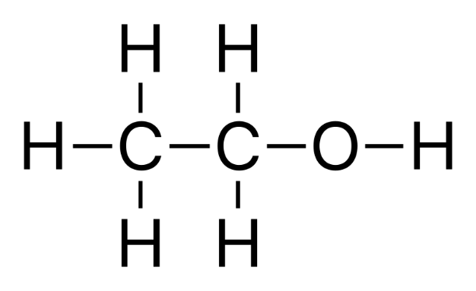

$$C_{2}H_{5}OHO_{2}+{3O}_{2}→2CO_{2}+{3H}_{2}O$$

*Equation 2: Combustion reaction of ethanol*

Figure 1: Diagram of ethanol compound

Its name also can be used to derive the chemical formula, ‘eth’, meaning it has two carbon atoms and ‘ol’ meaning it has and $OH$ functional group. Extra hydrogen atoms are then added to saturate the carbons bonds of the compound. In the combustion reaction it can be seen that the even though ethanol has a different chemical structure than the standard hydrocarbon ethane, the reaction shares the same products of carbon dioxide and water. Ethanol is primarily manufactured by fermenting starches in grains or sugars other plants. This is the same process used to create the ethanol found in alcoholic drinks. When producing ethanol in mass for the purpose of fuel a plant which has the most reactant compared to the environmental and economical to produce the plant should be chosen. One of these potential plants to be used in ethanol production is cassavas. Cassavas are a root vegetable native to South America and are similar to potatoes. They also happen to be chemically suitable as a source of ethanol as they contain a large number of reactants for the fermentation reaction which converts these to ethanol. As global reserves of fossil fuels dwindle and prices of petroleum rises, demand for cassavas for use in energy productions has increased (second report). This is due to many factors including being able to grow in various climates, requiring little farmer intervention, having the ability to grow in any season and the rapid growth of the plant. This evidence has led to the following research question:

*Is cassava-based ethanol production a viable and safe alternative energy source to petroleum?*

**Discussion of Evidence**

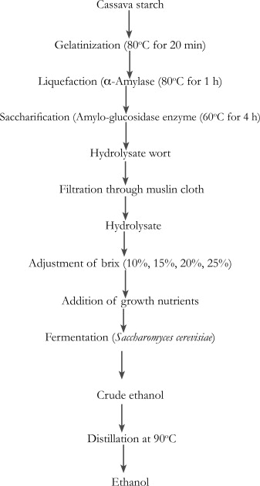When comparing the effectiveness of a fuel there are four major criteria. These are economic cost, available use cases, energy output and environmental impact. Since petroleum is still the dominant fuel around the world it overall is currently the most effective fuel (Prokosch, 2020). However, with the foreseeable scarcity of fossil fuels it is reasonable to assume that the economic cost will continue to increase. Therefore, even if there is no advancement in renewable technology there will become a time where it will become most effective out of necessity. Knowing this case, the search for the most effective renewable fuel becomes very important for society.

Figure 2 shows the process of converting cassava starch into pure ethanol. It shows that relative simplicity of the process and that it can be automated in on a large scale. The steps also do not have particularly harmful effects on the surrounding environment. This is unlike petroleum which requires drilling. This drilling disrupts ecosystems, requires the clearing of vegetation and has other environmental consequences. Like all hydrocarbons ethanol produces carbon dioxide, a harmful greenhouse gas. However, looking at the bigger process shows that carbon dioxide released by bioethanol is the same gas absorbed in the farming process making it more sustainable when compared to crude oil being pumped out of the ground. Overall, Figure 2 shows that the process of converting cassavas to a usable biofuel is safe and environmentally neutral.

Figure 2: Ethanol production from cassava starch (Ajibola et al., 2012)

According to the U.S. energy information administration the energy contents of pure ethanol is 33% lower than petroleum. This is not ideal, however to mitigate this issue ethanol is commonly used as a fuel additive to car fuel. This is a good short-term solution as it creates a demand for ethanol using existing engine technology. This shows that bioethanol is less space efficient when compared to petroleum. This is significant as modern vehicle’s travel range is constrained to the amount of chemical energy it can hold. This directly affects the viability of a fuel and how it can be used in society.

Figure 3 shows the results from an experiment converting cassava flower into ethanol using yeast as a catalyst. The different coloured lines represent different suppliers of cassava it shows after over 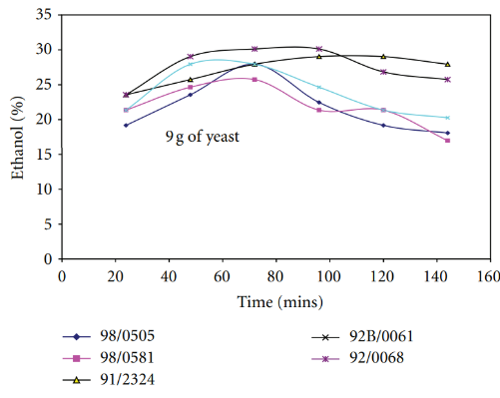the three-hour period ethanol concentration produced varied up to 50%. This shows that the type of cassava used in a fermentation reaction influences the yield of ethanol. It also shows that the cassava plant is a viable source of ethanol as the amount ethanol produced in the experiment was significant.

Figure 3: Ethanol yield for different cassava cultivars using 9 g of yeast (Ademiluyi & Mepba, 2013)

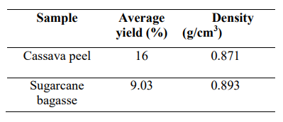Figure 4 shows the results from a different experiment comparing the yield of ethanol by fermenting cassava peels to sugarcane bagasse. It finds that the density of the ethanol is very similar however the percentage yield of the cassava peels is 77% higher. This means that of the two primary plants used in the production of bioethanol the cassava contains more reactants in the fermentation reaction. This further shows viability of ethanol as a source of energy as it outperforms its competing source of ethanol.

Figure 4: The Average Yield of Bioethanol (Isah, 2019)

**Evaluation of Evidence**

Figure 2 originates from The Nigerian Journal of Microbiology in 1998. This is a peer reviewed journal published by the Nigerian Society of Microbiology making it a reliable source. Its age however means that the method described may be outdated. A more effective method to convert cassava starch into ethanol has been found in the past 25 years since publication, however this does not affect the outcome of this report because it’s aim was to compare cassava’s ability from different producers and not find the highest potential cassava extraction process.

Figure 3 comes from a 2013 article published by the online, peer-reviewed, open access, scientific journals website, hindawi. The specific article was written by two academics from Rivers State University of Science and Technology in Nigeria which adds to the source’s credibility. It is also well cited itself and is cited in 19 other articles which means other scholars who wrote those articles also believe the original article is reliable. The age of this experiment also causes it to share the same issue of not utilising the most cutting-edge methods as the previous source.

Figure 4 was first published in a 2019 article making it the most recent of the three articles. Published in the Journal of Chemical Society of Nigeria. It uses a similar method compared to the article of Figure 1 using ground, dried cassava. However, this method compares this to sugarcane. This makes it more relevant as it is gives compares the statistics found in the previous article to a competing source of ethanol.

Many of the sources used in this research investigation are published in the country of Nigeria, this is because Nigeria is the largest producer of Cassavas in the world. This may be a cause of bias in the results because of economic pressures, however this is unlikely.

**Conclusion**

It was found that the production of ethanol is safer from an environmental point of view when compared to petroleum. The viability however is somewhat lacking as current infrastructure is mostly unable to utilize the benefits of pure bioethanol. This means that without significant adoption from engine manufacturers of a fuel which is less energy dense, ethanol is not a suitable replace for petroleum as the dominant fuel in modern society. Current ethanol production are not useless however, because of its use as a fuel additive in petroleum.

**Extensions**

This investigation could be extended in various ways. Data on the economic cost to allow current infrastructure to use higher concentration ethanol-based fuels would deepen the analysis of the viability of using ethanol as a source of energy. Also, data on the viability of the production of electrical energy created with ethanol would help extend the claim. Data on the energy per dollar of ethanol compared to petroleum would more definitively show the economic viability of bioethanol as a fuel source.

References

Ademiluyi, F. T., & Mepba, H. D. (2013). Yield and Properties of Ethanol Biofuel Produced from Different Whole Cassava Flours. *ISRN Biotechnology*, *2013*. https://doi.org/10.5402/2013/916481

Ajibola, F. O., Edema, M. O., & Oyewole, O. B. (2012). Enzymatic Production of Ethanol from Cassava Starch Using Two Strains of Saccharomyces cerevisiae. *Nigerian Food Journal*, *30*(2), 114–121. https://doi.org/10.1016/s0189-7241(15)30044-8

Hucknall, D. (2012). Chemistry of Hydrocarbon Combustion. Springer Science & Business Media.

Isah, Y. (2019). Comparative Analysis of Bioethanol Produced From Cassava Peels and Sugarcane Bagasse by Hydrolysis Using Saccharomyces Cerevisiae. Journal of Chemistry Society, 44(2). https://www.journals.chemsociety.org.ng/index.php/jcsn/article/download/263/317

Prokosch, P. (2020). *Petroleum*. WWF. https://wwf.panda.org/discover/knowledge_hub/teacher_resources/webfieldtrips/climate_change/petroleum/

U.S. Energy Information Administration. (2020, June 18). Ethanol explained - U.S. Energy Information Administration (EIA). Eia.gov.

https://www.eia.gov/energyexplained/biofuels/ethanol.php